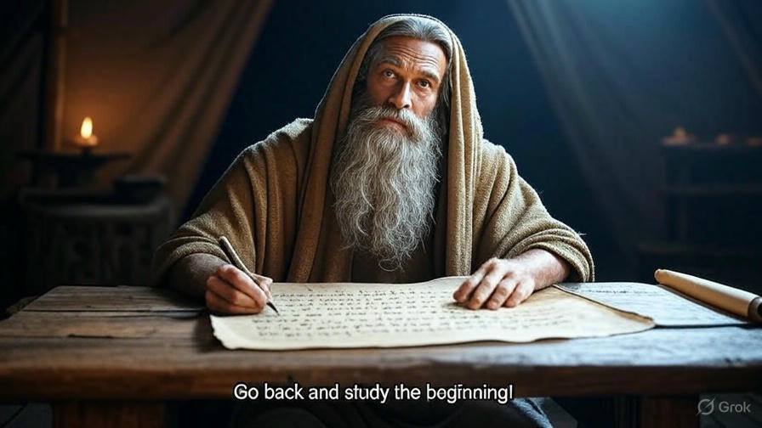
In the Beginning
Part 1

As we go back and study the beginning, let’s focus frequently on what we learn about God and what we learn about ourselves from the Old Testament.

I. Before Time Began
The Bible frequently refers to things that were true before the beginning. Here are some references for you to meditate on. We will cover the ones with the * in class.
*2 Timothy 1:9 *Titus 1:2
Proverbs 8:23,25 *John 17:24
*Eph 1:5 1 Peter 1:20
*Rev 13:8 Matt 13:35
Matt 25:34 *Psalm 90:2
On the next page write a short description of what all was going on before time began.

It’s About Time
Time itself deserves some attention. Time did not start until God created it at the beginning (2 Timothy 1:9). With God there is no “before” or “after.” He just is. He is outside of time. I believe that when God speaks to us in terms of time, such as “before” or “after,” He is accommodating the fact that we live in time. He does not.
James 1:17 Colossians 1:17
Exodus 3:14 Psalm 90:4
2 Peter 3:8 John 8:58
Isaiah 57:15 Rev 1:8
Heb 13:8 Rev 4:8

II. In the Beginning (Genesis 1:1 – 2:3)
Genesis 1:1
1. Who was the original audience for the first five books of the Bible?
2. In the beginning God. Hebrew word – Elohim
Generic word for God or god.
“You shall have no other elohim before me” (Ex 20:3).
Regarding the golden calf they said, “This is your elohim
O Israel, that brought you out of Egypt” (Ex 30:4).
3. Read and make a list of all the things God did in
Genesis 1:1 -2:3. For instance: God Created (1:1); God said (1:3), etc. I’ve left space for you on the last page (pg 12).
4. John 1:1-3; 10– John says that the Word was in the beginning and that the Word was God. Where is the Word in Genesis 1? What did the Word have to do with creation?
5. Meditate on Psalm 33:6-9. What should the response of the inhabitants of earth be to God’s creation? Why?

Genesis 1:2
1. Verse 2 says that the earth was without form, and void. The Hebrew words are “tohu” and “bohu.” Let’s check out how these words are used other places in the Bible. Look up each reference below; I will tell you the English word and which Hebrew word is used in that verse. At the end I’ll provide a space for you to write your definition of these two words when used together.
Deut 32:10 wasteland – tohu
1 Sam 12:21 empty things – tohu
Job 6:18 nowhere – tohu
Job 12:24 wilderness – tohu
Job 26:7 empty space – tohu
Psalm 107:40 wilderness – tohu
Isaiah 24:10 confusion – tohu
Isaiah 29:21 empty words – tohu
Isaiah 34:11 confusion – tohu; emptiness – bohu
Tohu also in Isaiah 40:17; 40:23; 41:29; 44:9; 45:18; 59:4
Jeremiah 4:23 without form – tohu; void – bohu
Based on these passages, how would you define this phrase without using the words “form” or “void”?

2. Based on verse 2, what other conditions prevailed on the earth at this stage? (Deep = flood or deluge)

3. Why do you think the earth was in this condition? Look up Isaiah 45:18. How did God NOT create the world? Why was it empty, formless, dark, chaotic and watery? Skimming through Jeremiah 4 with a focus on verses 23-26, and Isaiah 34 with a focus on verses 8-11 might help.

Look up Rev 21:1 and 22:5. What is the difference between those descriptions of the new earth and what we find in Genesis 1:2? Does that tell you anything?

4. Write some thoughts about the word “moved,” or “hovered,” or “brooded” in verse 2. What do you picture in your mind when you think about this?

5. Explain where the three persons of the trinity are present in Genesis 1.

Genesis 1:3 - 5
1. God commanded light to exist, and it obeyed! What was God’s response to the light? (Hebrew = tōv)
How does Romans 4:17b relate to events in the creation account?

How does Hebrews 11:3 add to our understanding of creation?

In 2 Corinthians 4:6, Paul speaks of “the God” who spoke light into existence at creation and applies it to what other situation?

See also Isaiah 45:7. Any thoughts on this passage?

2. Besides seeing that the light was good, what else did God do in verse 4? Skim the creation account. What other things did God divide or separate?

3. In verse 5, What did God call the light and the darkness?

4. Verse 5 ends with, “There was evening, there was morning, day one.” Do you see any significance in putting evening first? We usually speak of days being morning and evening.

Genesis 1:6-8
1. What did God command into existence in verse 6 and what did He want it to do? (Also see Psalm 148:4)

2. Ancient Hebrews viewed the firmament (Hebrew=raqia) as a solid dome separating waters above from waters below. The root word raqa means to beat out a piece of metal to make a thin sheet.
The Bible says that the sun, moon, and stars were placed in the raqia (Genesis 1:14-20). The raqia is also what declares God’s glory in Psalm 19:1; and is where the righteous shine in Daniel 12:3.
Most English translations view it as an expanse or space that would include outer space where the planets and sun, moon, and stars are.
3. Just as in verse 5, God names what He has made. What did He name it?

4. Verse 8 ends with “There was evening. There was morning. Day two.
Genesis 1:9-13
1. Does verse 9 describe the creation of anything new? This is another instance of separation.
2. What names did God give to the two parts? (Verse 10)

3. What was God’s assessment? (Again tōv)
4. In verse 11, who is the command directed to, and what was to be the result?

5. What does “after their kind” mean? Why is that important?

6. What happens in verse 12?

7. Verse 13 concludes day 3.

Genesis 1:14-19
1. God now creates light bearers to hold the light that God created on Day 1. What is the separation that occurs here?

2. What are their 5 purposes?

3. What is the overall purpose in verse 15?

4. In verse 16, one great light had dominion over the day, and a lesser light had dominion over the night. He made the stars as well.

5. What action did God take then in verse 17-18?

6. This ends day 4.
Genesis 1:20-23
1. Who was the command in verse 20 directed to, and what was the result?

2. Again, the phrase “after their kind” was used. It was so and what was God’s assessment?

3. What do you make of the fact that God blessed the sea creatures and birds? Does that have something to do with the command to multiply? How was that a blessing to them?

4. There was evening. There was morning. Day 5

Genesis 1:24-31
1. What did God command next? … and it was so.
And what was God’s assessment?

2. In verse 26 God said, “Let us make man in Our image…”
Why “us” and “our”?

3. In what ways do you think God created us in His image? (Image means likeness, replica, icon, idol)

4. What was mankind’s responsibility?

5. What do you think having dominion entails?

6. Discuss the importance of “male and female” especially in light of modern discussions of gender.

7. God blessed them and said, “Be fruitful and multiply; fill the earth and subdue it and have dominion.” What are your thoughts on this section? (v. 29)
Blessed
Fruitful
Subdue
Dominion

8. What food did God provide for mankind? How did man’s food differ from animal’s food in the next verse?

9. What was God’s assessment of the entire creation project at the end of day 6? (Hebrew = tōv mĕ’ōd)

Genesis 2:1-3
1. The creation work was done. According to Genesis 2:3, what are the two things God did to the seventh day? … and why?

New Testament Connections
Read and meditate on these passages from the New Testament and jot down any thoughts that come to mind.
John 1:1-3, 10; Colossians 1:16-17; Heb 1:2-3; Rev 4:11;
Acts 17:24-26; Eph 3:9b; Matt 19:4-6

As we think about all we have read and thought about from Genesis 1, what do we learn about God, His character, and His assessment of the creation He has made? Think about the difference between the darkness and chaos that existed in the beginning and where things stand as we conclude Genesis 2:3. Does just this much of the Bible give us any clues as to what God is trying to accomplish?
What did you learn about yourself in this section?

List of all things God said or did in this passage:
God created – Gen 1:1
Spirit hovered – Gen 1:2
God said – Gen 1:3

